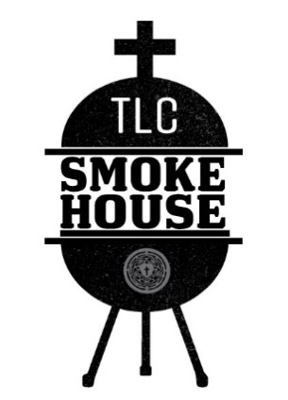
TLC Smokehouse
1267 E Highway 7, Clinton, MO 64735
www.trinityclintonmo.com/smokehouse

Smokehouse Policy
The TLC Smokehouse provides the food truck, utensils, food, and cashier to help local organizations raise funds for their projects. The organizations provide the volunteer workers serve the food and help with the setup and cleanup.

When a customer orders from our truck, they choose which organization to support with their purchase. 10 percent of their order plus any tip goes to the chosen organization.

You are required to provide workers for the Smokehouse. Please line up your working crew before April 1. A working crew consists of a Crew Chief and at least four volunteers.

The Smokehouse schedules both one day and multiple-day events between April 1 through September 30. Brent Viebrock will use SignUp Genuis to let everyone know the upcoming event and allow crew members to sign up for work shifts. Your organization will be required to provide at least one worker each day the Smokehouse is open.

Penalty for not providing workers
The Smokehouse gives your organization the opportunity to raise money for your cause by providing volunteer workers. If your organization does not work the events, you will not receive the full percentage from a sale. It will be decreased at the discretion of the Smokehouse management. You will receive any tips left for your organization.

Brent Viebrock
Head Chef – TLC Smokehouse
Trinity Lutheran Church
1267 E. Highway 7
Clinton, MO 64735
660-287-7569

